
Technical Information Document
COE
Servers

Document Title: | How to install manually NEC IPMI driver for BMC (NECRAS.SYS) ?
Document ID: | TID0404271128
Creation Date: | 27 April 2004
Modified Date: | 24 Novembre 2008
Document Revision: | 1
Product Class: | Servers
Product and Version: | Any server with ESMPRO/Dianascope Agent for Windows

Symptoms / Facts
ESMPro//Dianascope Agent requires NECRAS.SYS to install.

Cause
NECRAS.SYS is the NEC IPMI driver to communicate with BMC.
This driver is mounted either when
- When Windows is installed by ExpressBuilder
- When NEC Update software is applied
But those two solutions are applicable only with Western Europe languages.

Solutions / Fixes

There is a manual way to install this driver.
Follow the instructions (ExpressBuilder CD associated to server is required):

- Once Windows installation is finished, create a folder C:\TEMP\
- Copy from ExpressBuilder NECRAS.SYS and NECRAS.INF files to C:\TEMP\
Note: For Windows2000, source files are located into: \WINNT\W2K\RAS
For Windows2003, source files are located into: \WINNT\DOTNET\RAS_A
- Copy from ExpressBuilder RASINST.EXE files to C:\TEMP\
Note: For Windows2000, source file is located into: \WINNT\W2K
For Windows2003, source file is located into: \WINNT\DOTNET
- Open a command line session, and make C:\TEMP\ as current directory
- Type the following command

RASINST.EXE c:\TEMP\necras.inf root\necras

- In order to check installation finished successfully, open device manager and enable the display of hidden devices:
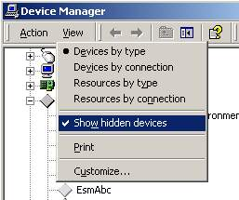

7) Open the category “Non-Plug and Play Drivers”, if the installation is successful, the line “NEC Baseboard management controller” should appear:
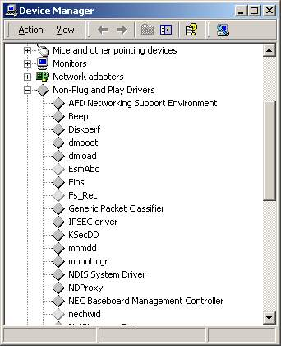

Document owner: | COE Servers
Applies to: | Any Server with ESMPRO//Dianascope Agent for Windows

