
Technical Information Document
COE
Servers

Document Title: | How to save ESMPRO Data Viewer information
Document ID: | TID0501061120
Creation Date: | 06 Jan 05
Modified Date: | 16 May 07
Document Revision: | 1
Product Class: | Servers
Product and Version: | ESMPRO Server Manager (all versions).

Data Viewer Overview

ESMPRO Data Viewer provides the server administrator with a graphical real-time interface into the hardware and software operation of their server. The information provided by the Data Viewer can assist in diagnosing any faults that may occur.

Instructions are provided here on how to save the information available with Data Viewer into a format suitable for sending to Bull support staff.

Saving Data Viewer Information

- Start the Data Viewer session for the required server.
- Right-click on the root of the tree displayed and select copy.

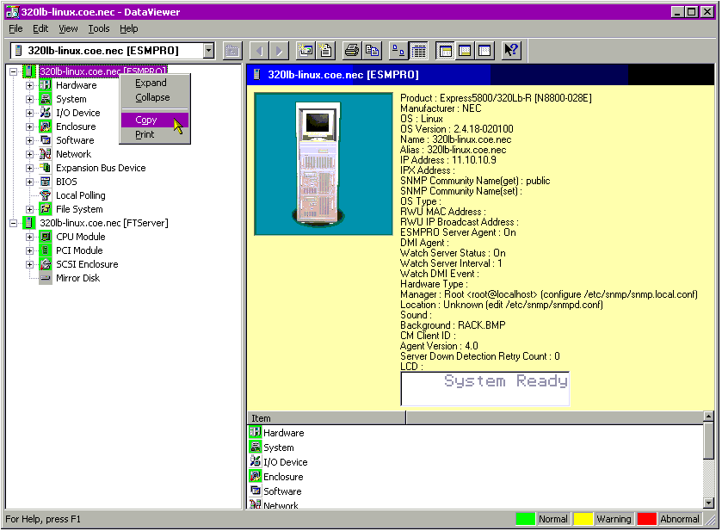
You will be told this operation will take several minutes to run.
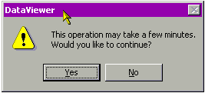
Select Yes. The Data Viewer will now automatically move through the tree collecting relevant information about the server, storing it in the clipboard.

- Load Notepad and select ‘Edit / Paste’. The contents of the clipboard (the Data Viewer information) will be pasted into the text file.

Important note: if the server is a fault-tolerant server (as is the case in the above example) you will additionally need to ‘Right-click / Copy’ the ‘[FTServer]’ section of the tree and paste this to the end of the text file. This ensures that all information about the server is recorded.

- This text file can be saved and emailed to Bull support as required.

Document owner: | COE Servers

