
Technical Information Document
COE
Servers

Document Title: | Integrating ESMPRO into HP Openview Operations Console
Document ID: | TID0501191045
Creation Date: | 19 Jan 2005
Modified Date: | 23 Jul 2007
Document Revision: | 1.1
Product Class: | Servers
Product and Version: | All server platforms and all versions of ESMPRO

Overview

The paper provides information on how to forward ESMPRO alerts into the HP Openview Operations Console management software. It is assumed that the reader of this paper has a good knowledge of the two management applications.

Architecture Requirements

The following ESMPRO architecture is assumed:

- Each server sends their ESMPRO alerts to a central ESMPRO Manager workstation using the ‘TCP/IP In-band’ method.
- The ESMPRO Manager will forward the alerts to the HPOV Operations Console (running on either the same workstation or a different one).
- Each managed server and the ESMPRO Manager workstation need to be configured as a “managed node” within HPOV Operations Console.

Required bath file

On the ESMPRO Manager workstation, create a batch file called SendOvMsg.bat in the C:\TEMP directory. This batch file should be as shown below:
C:\temp\SendOvMsg.bat
@echo off
rem SendOvMsg.bat %a %i %n %r %s %t

set logfile=c:\temp\log.txt

echo ------------------------------- >> %logfile%
echo (a)alerttype= %1 >> %logfile%
echo (i)eventid= %2 >> %logfile%
echo (n)trapname= %3 >> %logfile%
echo (r)servername= %4 >> %logfile%
echo (s)eventsource= %5 >> %logfile%
echo (t)time= %6 >> %logfile%
goto main
echo %7.
echo %8.
echo %9.
echo -----

:main
rem ** Translate ESMPRO severity in HPOV equivalent **
echo %1 | find "nformation"
if not errorlevel 1 set %severity=Normal

echo %1 | find "ajor"
if not errorlevel 1 set %severity=Major

echo %1 | find "inor"
if not errorlevel 1 set %severity=Minor

rem *** Remove following line if you do not want to filter major alerts only.
if not %severity% == Major goto end

rem ** Write command to log file and then execute it **
echo opcmsg a="ESMPro" n=%4 o=%5 severity=%severity% msg_text=%3 >> %logfile%
opcmsg a="ESMPro" n=%4 o=%5 severity=%severity% msg_text=%3

:end

This file will be used later to forward major alerts only to HPOV (edit the file as indicated to remove this restriction). It additionally creates a log file of its actions.

ESMPRO Agent Configuration

For each server, configure the ESMPRO Agent to send alerts, using the TCP/IP In-band method, to a central ESMPRO Manager workstation.

- Modify group settings for Manager group to only include TCP/IP In-Band destination.
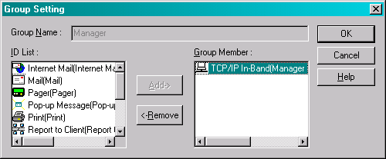
- Modify TCP/IP In-Band settings to include IP address of workstation running ESMPRO Manager, for example.
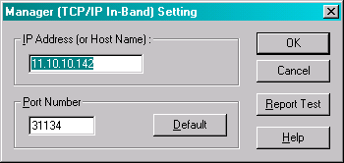
The workstation running ESMPRO Manager will now receive alerts from the servers.

ESMPRO Manager Configuration

ESMPRO Manager needs to be configured to execute the attached SendOvMsg.bat batch file whenever it receives an alert. This batch file will forward the alerts to the HP Openview Operations Console by using the opcmsg.exe program provided with HPOV.

- Create a new destination ID of type “Run Command” …
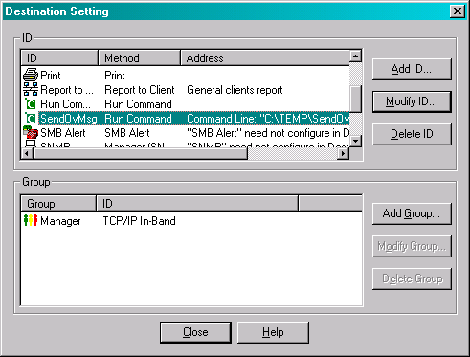
…to run the SendOvMsg.bat batch file. The batch must be provided the following parameters in the order specified.
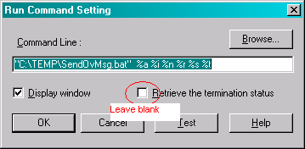

- Identify each server being monitored by ESMPRO…
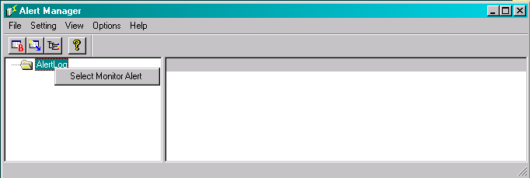
…and select all alert types for the server, e.g.:
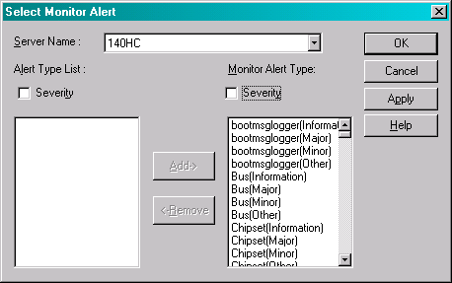

- Select the destination for all alerts for this server…
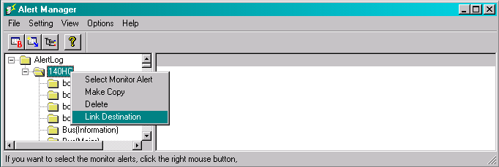
…to be the SendOvMsg method (i.e. the batch file)
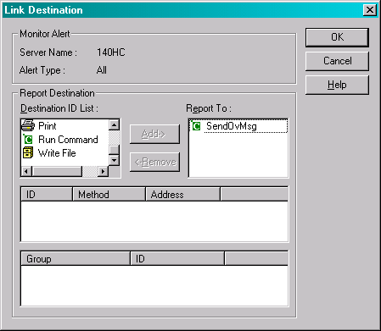
Result:
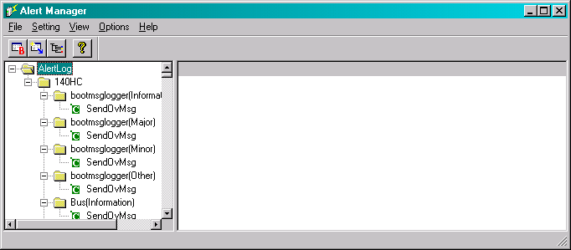

Now, whenever ESMPRO Manager receives alerts from a defined server, it will execute the batch file, which will then use opcmsg to send the message to HPOV.

HP Openview Configuration

The ESMPRO Manager workstation must be configured within HPOV to have the appropriate privileges to send messages into the HPOV environment. This is done but using HPOV to deploy the appropriate policy.

- Using the HPOV Operations Console, select the opcmsg policy from the Open Message Interface policy group and deploy it onto the workstation running ESMPRO Manager.
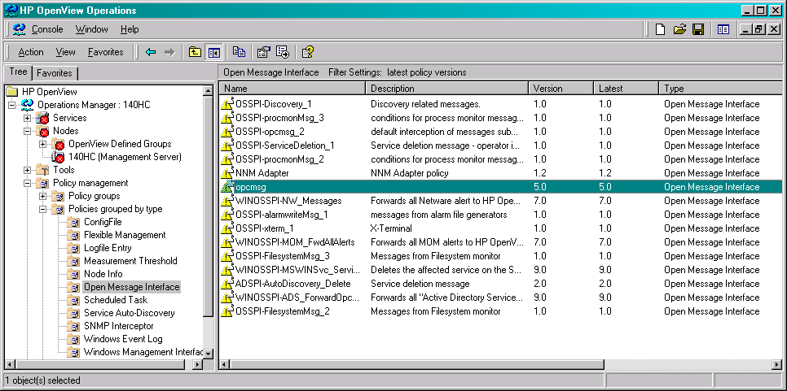

With everything configured HPOV will now receive messages from ESMPRO.
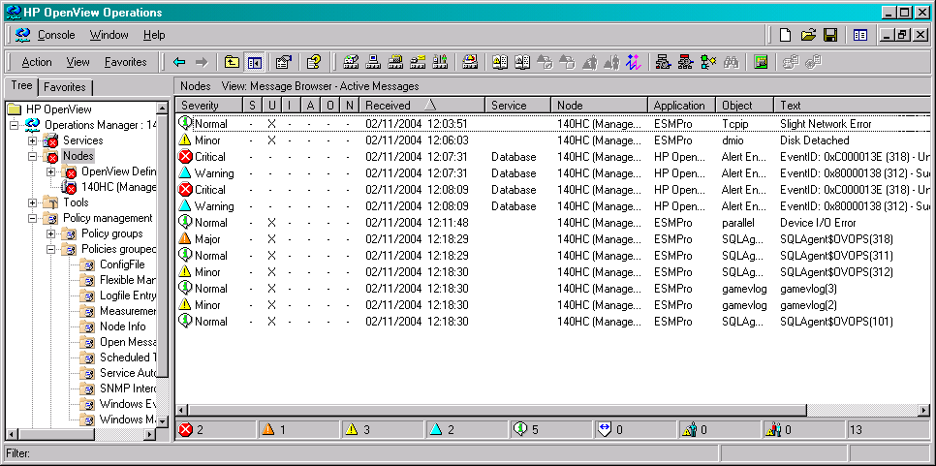

Note that, although these alerts are sent to HPOV, ESMPRO should still be used to diagnose the problem.

Document owner: | COE Servers
Applies to: | All servers

