
Technical Information Document
COE
Servers

Document Title: | MSI Installer error 1601 during DianaScope Manager installation
Document ID: | TID0509231031
Creation Date: | 23 Sept 05
Modified Date:
Document Revision: | 0
Product Class: | Servers
Product and Version: | DianaScope

Symptoms / Facts

During DianaScope Manager Installation, after IP address range and Administrator name entry, you get the following error message

Error:-1601 the windows installer service could not be accessed. You may be running in Safe mode or Windows Installer may not be correctly installed."

Screen shot on French Windows

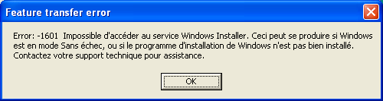

Cause

MSI installer gets corrupted

Workaround

This issue can be solved by reconfiguring MSI Installer. 3 possible methods

A - Register MSIEXEC
To resolve this problem, shut down the Windows Installer service and then re-register it. This makes sure that the Windows Installer engine functions properly. To do this, follow these steps:

1. Click Start, and then click Run.
2. In the Open box, type msiexec /unreg, and then click OK.
3. When this process is complete, click Start, and then click Run.
4. In the Open box, type msiexec /regserver, and then click OK.
5. When this process is complete, try the install again

B - Deleting pending install

1. Go to Start, run and type regedit.
2. Navigate in the registry editor to
hklm\software\microsoft\windows\currentversion\installer\inprogress
3. Click on the inprogress key and note the name of the file listed on the
right side for databasepath (should be have a .msi extension).
4. Rename inprogress to oldinprogress.
5. Close the registry editor.
6. Open My Computer.
7. Navigate to C:\Windows\Installer (Installer folder is hidden by default) and rename the file noted in step 3.
8. Reboot the computer and try the install again.

C - Updating MSI Installer

1 From Microsoft web site, download the MSI Installer package:
http://www.microsoft.com/downloads/details.aspx?FamilyID=cebbacd8-c094-4255-b702-de3bb768148f&displaylang=en
2 Install it and try again the install

See also (if applicable)

Document owner: | COE Servers
Applies to: | DianaScope Manager on Windows

