
Technical Information Document
COE
Servers

Document Title: | T840 and ESMPro Agent
Document ID: | TID0611221553
Creation Date: | 22 Nov. 2006
Modified Date: | 26 Jan. 2007
Document Revision: | 1
Product Class: | Servers
Product and Version: | NovaScale T840

How to install ESMPro Agent ?

NOTE:
- For machine produced before 20th November 2006 (see date on chassis label), update fully the system with BOOT_CD 1.0.5 (or more) available on support part of http://support.bull.com.
- Expressbuilder DVD TM-7.1.0 or more is required.

- Use Expressbuilder CD version TM-7.1.0 or more.
- Install BMC driver using the following command

For Windows 2003 x32: \RECOVWK3_32\I386\$OEM$\INSTALL.BAT
For Windows 2003 x64: \RECOVWK3_64\AMD64\$OEM$\INSTALL.BAT

- Accept the driver installation

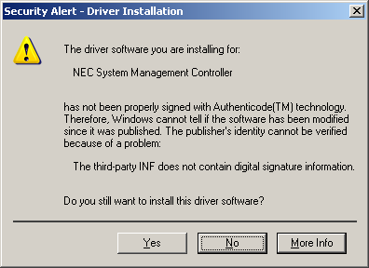

- To check if install is successful, go into device manager, check the box “Show hidden device”, and open “Non Plug and Play devices” category:
If driver installed properly, “NEC Baseboard Management Controller” should appear without question mark.

- Install ESMPro Agent with following path

\APPS\ESMPRO\EN\WINNT\AGENTW2K\SETUP.EXE (Windows x32 and x64)

Potential problems

NECRAS.SYS doesn’t start (Source: NECRAS ID:3)

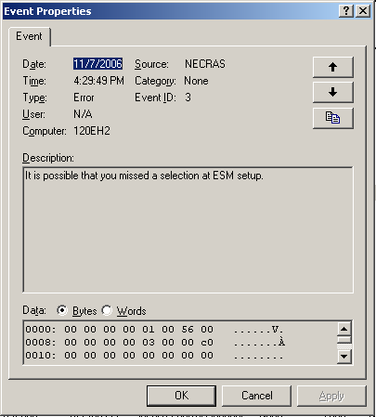

- update fully the system with BOOT_CD 1.0.5 (or more).

ESMPro services crashed on operating system start up (ESMFS.EXE)

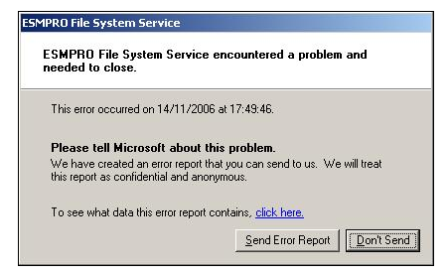
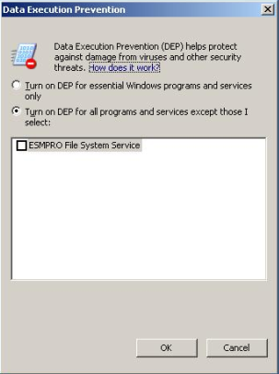

- ESMPro Agent is only qualified on following operating system:

Windows 2003 R2 Standard Edition/Enterprise Edition
Windows 2003 R2 Standard x64 Edition/Enterprise x64 Edition

Document owner: | COE Servers
Applies to: | Bull NovaScale T840

