
Technical Information Document
COE
Servers

Document Title: | Unable to boot a R440 or R460 with SAS controller
Document ID: | TID0703191431
Creation Date: | 19 Mar. 07
Modified Date:
Document Revision: | 0
Product Class: | Servers
Product and Version: | R440 & R460

Symptoms / Facts
The machine is locked on POST on LSI Megaraid RAID SAS BIOS on board controller initialisation with the following message:
“Bringing up the Controller. Please wait…”

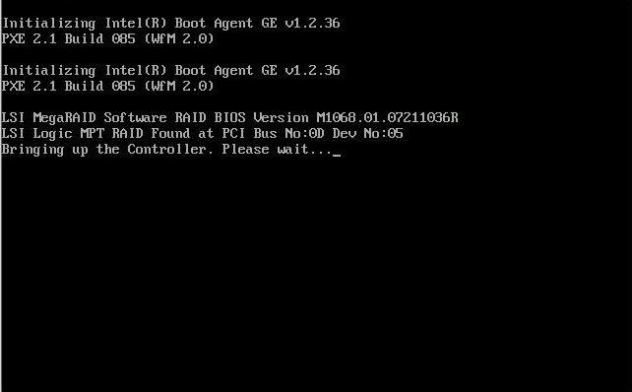

Cause
The jumpers are not set correctly on the motherboard.

Solutions / Fixes
- Power off the machine
- Unplug the power cable
- Set correctly the jumper RoMB for RAID configuration
  - jumper number 12 on “Server Hardware Quick Reference” sticker (on the small front top cover FAN)
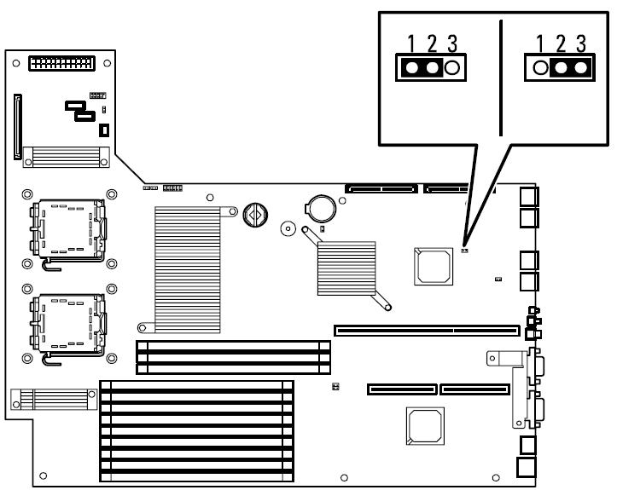
  - This jumper will enabled or disabled the RAID on board feature depending on the customer requirement

RAID
disable
RAID
enable
- Set correctly the jumper number 6 on “Server Hardware Quick Reference” sticker (on the small front top cover FAN). This jumper must be set in “Factory default” mode 2-3. The other position must never be used.
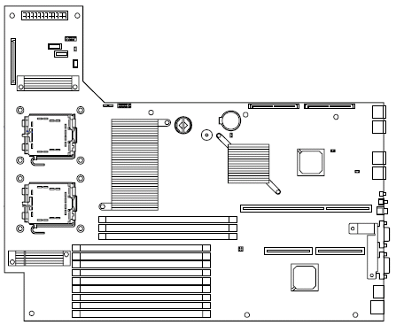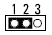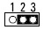
Never used
Factory Default
- Power On the machine
- The issue should be solved. Please do not forget to update BIOS, BMC and SDR using the last BOOT_CD.

See also
The following picture will show you all the jumper location and function for R460 and R440.
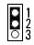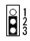
Non-Raid

Raid
Only SAS version
Normal

Clear CMOS
Normal

Clear PWD
Fan Normal

Fan Redundant

In R440 Version,
always « normal »
position used
In R460,
« normal » or
« redundant »
according to fan
configuration

Never used
Factory Default
Only SAS version

Document owner: | COE Servers
Applies to: | R440 / R460

