
Technical Information Document
COE
Servers

Document Title: | How to update RICC Minicom Firmware and KVM Minicom SMART CAT5 Firmware
Document ID: | TID0704161503
Creation Date: | 16 Apr. 07
Modified Date:
Document Revision: | 0
Product Class: | Servers
Product and Version: | All

Smart Switch Upgrades

You can find this work instruction on Minicom Web-Site.
http://www.minicom.com/phandlc.htm
Some firmwares are specific for Bull. Please follow the Bull recommendation and obtain the last Firmware. If you flash a wrong Firmware, your system could work improperly.

If Your Smart CAT5 Switch System works properly you shouldn't update its firmware. You may need to reboot your computers after firmware upgrade.

All Smart CAT5 Switch Software support 32 bit Windows only. Currently there is no intention to support other operating systems.

Smart CAT5 Switch Software
Smart CAT5 Switch Software version 1.6
Download Smart CAT5 Switch Update software version 1.6 for performing flash upgrade to Smart CAT5 Switch and RICC units. (Through RS232 line)
Smart CAT5 Switch RS232 Control Software version 1.7
Download Smart CAT5 Switch RS232 Control Software version 1.7 to control and operate Smart CAT5 Switch System. (Through RS232 line)
Smart CAT5 Switch Firmware
There are multiple hardware versions of Smart CAT5 Switch units, each with version specific firmware. Please use the descriptions and diagrams below to identify your version.
To identify the hardware version of the Smart CAT5 Switch, run the Smart CAT5 Switch Update software, select the Smart CAT5 Switch Manager and press H/W Version button.
Note the hardware ID of the Smart CAT5 Switch Manager unit.
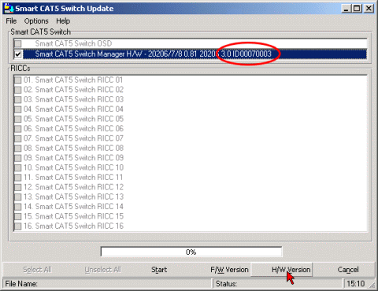
Click on Firmware Version number to download the firmware files. The downloaded file archived in zip format. Unzip it to temporary folder. You will see two files - one for the Smart CAT5 Switch OSD and another for the Smart CAT5 Switch Manager. First upgrade the OSD and then upgrade the Manager. Please refer to user guide or software on-line help for more information on upgrading the Smart CAT5 Switch units.
Hardware ID | Firmware Version | Description | Date
ID00070003 | Manager: 1.4 | Manager only.  - Fix for Asterisk key opening OSD if OSD hotkey set to Print Screen | 2006-10-24  FCR 6092
ID00070003 | Manager: 1.3 | Manager only.  - Mouse operation improvement when Cirque touchpad connected to Smart CAT5 Switch  - Don't use this firmware when not a Cirque mouse connected to the switch. | 2006-05-10  FCR 6096
ID00070003 | OSD: 1.10  Manager: 1.1 | OSD and Manager.  - Faster programming of monitor DDC information.  - OSD hotkey response improvement when connected to switched off computer. | 2005-12-14  FCR 6098
ID00070003 | OSD: 1.10  Manager: 1.05 | OSD and Manager.  - Monitor DDC information programmed to all RICCs (Shift-Shift-F10 function).  - Keyboard LEDs don't switch on when OSD is open to prevent compatibility issues with some keyboards.  - Update of RICC status when working with RS232 Control software. | 2005-02-23  FCR 6097
ID00070003 | OSD: 1.10  Manager: 1.01 | OSD and Manager. OSD fix in Security window. Backspace key now works correctly | 2004-07-05  ECO 2346
ID00070003 | 1.01 | OSD and Manager. Automatic Link Update | 2003-09-21  ECO 3288
ID00070001 | 1.00 | OSD and Manager. Initial Release | 2003-05-28

- Firmware for SmartRack 16 Switch.
Hardware ID | Firmware Version | Description | Date
ID00070004 | Manager: 1.1 | Manager only.  - Fix for Asterisk key opening OSD if OSD hotkey set to Print Screen | 2006-10-24  FCR 6093
ID00070004 | 1.0 | OSD and Manager. Initial release | 2005-11-10

RICC Firmware
There are multiple hardware versions of RICC units, each with version specific firmware. Please use the descriptions below to identify your version.
To identify the hardware version of the RICC, run the Smart CAT5 Switch Update software, select all the RICC and press H/W Version button.
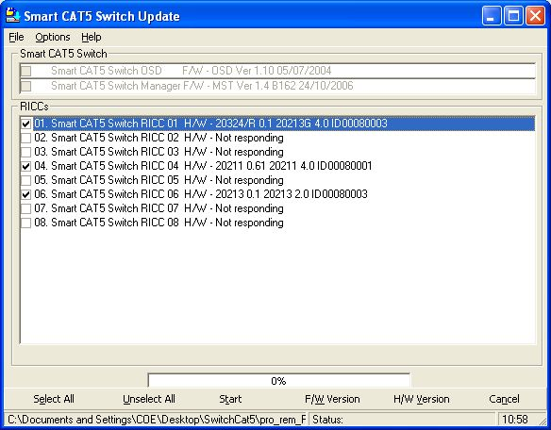
Note the hardware ID of the RICC unit.

- Firmware for RICC PS/2
  - Mnicom p/n 1SU51019 Hardware 20211 0.61 20211 4.0 ID00080001
  - Part Number
    - 6929960000 KVM RICC PS2
    - 8014190000 KVM RICC PS/2 ROHS
  - Version “pro_rem_PS2_M_v1_6_B121_20070401_E.hex”.

- Firmware for RICC USB
  - Mnicom p/n 1SU51020 Hardware 20213 0.1 20213 2.0 ID00080003
  - Part Number
    - 6929970000 KVM RICC USB
    - 8014200000 KVM RICC USB ROHS
  - Version “Pro_Rem_USB_v2.1_B92_2005.11.23_E.hex“

- Firmware for RICC USB developed especially for Fault Tolerant System (see TID0704161501)
  - Mnicom p/n 1SU51083 Hardware 20324/R 0.1 20213G 4.0 ID00080003
  - Part Number
    - 8028000000 KVM RICC USB ROHS FT
Related Links:
- SmartSwitch2-2.pdf - Resetting Lost Password In Smart CAT5 Switch.

See also
TID0704161500 Graphical mode is not working under LINUX operating system
TID0704161501 USB RICC Minicom is not working correctly on R620
TID0704161502 PS2 RICC Minicom is not working correctly on ServerEngines Pilot Chipset

Document owner: | COE Servers
Applies to: | All

