
Technical Information Document
COE
Servers

Document Title: | How to integrate RAID event into ESMPro alert?
Document ID: | TID0705041331
Creation Date: | 04 Mai 2007
Modified Date: | -
Document Revision: | 0
Product Class: | Servers
Product and Version: | Express5800 and NovaScale Universal R400, T800 Servers

First of all, refer to TID0310071000 on how to set alert from Agent to Manager in a reliable way (TCP/IP In-Band)

Configuring ESMPRO Agent
Once ESMPRO agent installed on Server side, following items have to be configured:
- Destination settings
- Local Event to be monitored

Local Event to be monitored
ESMPRO Agent is able to produce alert from EventLog of Windows. Name of the service to be monitored is required. Please refer to table hereunder for reference.

“Application” class is to monitor software,
“System” class is to monitor driver (that’s to say hardware)
“Security” is to monitor security.

RAID
Controler | Source | Type
Mylex | Gamevlog | Application
LSI SCSI | MegaServ.Log | Application
LSI SAS | MR_Monitor | Application
Adaptec HostRAID | ASMBENotify | Application
Promise FastTrack | PromiseMessageAgent | System
Promise IDE | FastCheckMon and FastTrack | System
Promise SuperTrack | WebPaMNotifier | System

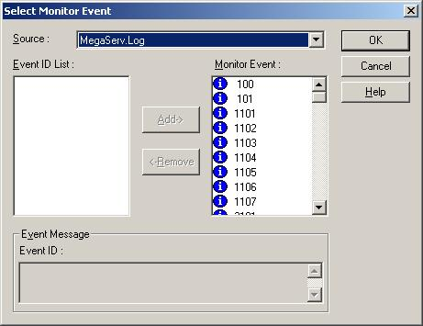

The following example is based on service installed by Power Console Plus (MegaServ.log) from LSI in order to monitor RAID activity.
NOTE: lot of RAID Management software are already interfacing with ESMPro Agent.

- Right click on Application and click “Select Monitor Event”

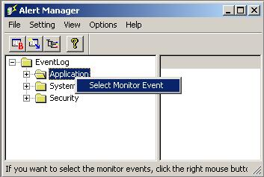

- In the list, select the source to be monitored (MegaServ.log in this example).
About eventID: based on your experience of Windows EventLog, select relevant ID and click “Add”.
Note: If all IDs are selected, ESMPRO manager will be overloaded of unjustify alert
Click OK

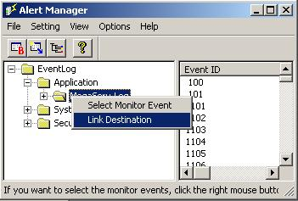

- Now, this new source is listed in application class. Link this source with the right destination by right clicking on “MegaServ.log” and click “Link Destination”

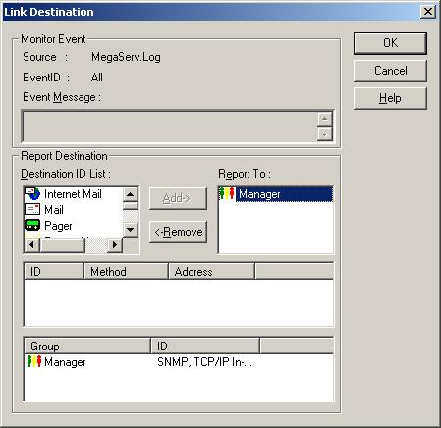

- Select “Manager”, click “Add->” and ok.

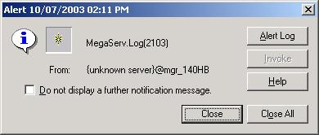
- On management station, open ESMPRO Manager and then Alert Manager window. As soon as an event occurs in RAID, you get a pop up window informing there is something new.

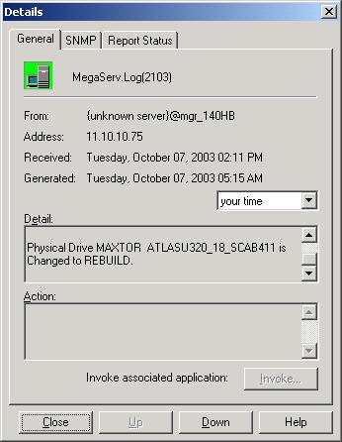

- If you open the object in AlertViewer you get the detail about the warning. In this example, a new disk starts rebuilding.

Document owner: | COE Servers
Applies to: | Express5800 and NovaScale Universal R400 and T800 Servers.

