
Technical Information Document
COE
Servers

Document Title: | Unable to install 64 bits OS under VMware ESX 3.0.1
Document ID: | TID0705211054
Creation Date: | 21 May 2007
Modified Date:
Document Revision: | 0
Product Class: | Servers
Product and Version: | 120Rh-2

Symptoms / Facts
You are not able to install a Windows 64 bits or Linux 64 bits.

When you boot on Windows 2003 R2 64 bits, you have the following error message:
“Attempting to load an x64 operating system, however this CPU is not compatible with x64 mode.
Please install a 32-bit X86 operating system. Setup cannot continue. Press any key to exit”
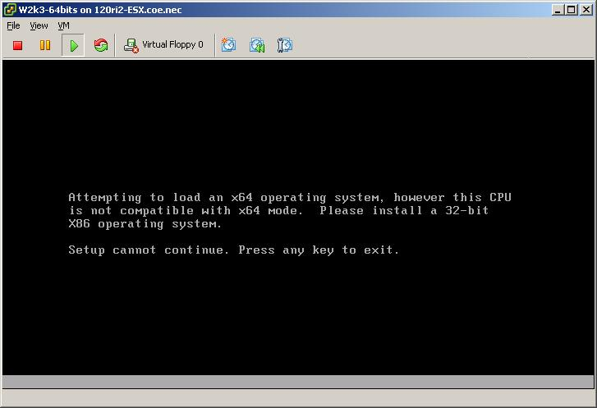
With a Linux RedHat 4 update 4 64 bits, you have the following error message:
“Your CPU does not support long mode. Use a 32bit distribution.”
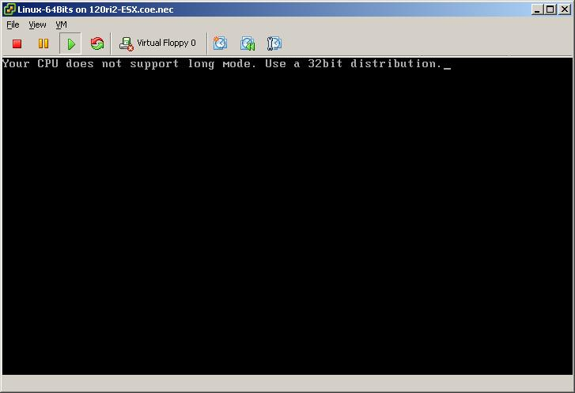
Cause
The Virtual CPU inside the VM is in 32 bits mode.

Solutions / Fixes
To support 64 bits, guest OS need VT-capable CPU. However, CPU in 120Rh-2 does not support VT function. So you can not install 64bits guest OS into 120Rh-2.

If you need more details please have a look on VMware “Guest Operating System Installation Guide”.
This guide could be find on VMware Website :
http://www.vmware.com/support/pubs/vi_pubs.html

For more information about support for 64 bit virtual machines on 32 bit Intel hardware, refer to knowledge base article 1901 at kb.vmware.com/kb/1901.
http://kb.vmware.com/kb/1901

Document owner: | COE Servers
Applies to: | 120Rh-2 and VMware ESX server 3.0 / 3.0.1

