
Technical Information Document
COE
Servers

Document Title: | ExpressScope and French keyboard layout issues on Remote KVM
Document ID: | TID0705251650
Creation Date: | 25 may 2007
Modified Date:
Document Revision: | 1  2 add firmware update
Product Class: | Servers
Product and Version: | All server offering Expressscope features (R440, R460, T860, T820…)

Symptoms / Facts

When using the “KVM over IP” feature of ExpressScope (a.k.a. “Remote KVM”), some keys pressed on remote console give different characters on server side when using French keyboard.

Example: On a PC connected to a R460. Both using french keyboard layout.
When the key ‘A’ is pressed on PC, the letter ‘Q’ appears on server.

Cause

Keyboard layout defined in operating system of remote console machine and server are both impacting the KVM behaviour.

The Remote KVM of ExpressScope is not supporting properly the french keyboard with first version of firmware of Expressscope (a.k.a. BMC firmware). French keyboard has been implemented with new versions:
Version | Keyboard layout supported
00.51 or less | English only
00.53 or more | English and French

This BMC firmware 00.53 is implemented on BOOT_CD started from version 1.0.12.
Refer to support web site to get it.

Notice: this new version 00.53 can only be used on R440 / R460 machine.

How to check your BMC firmware version ?

Firmware Revision can be obtained by clicking “Help”
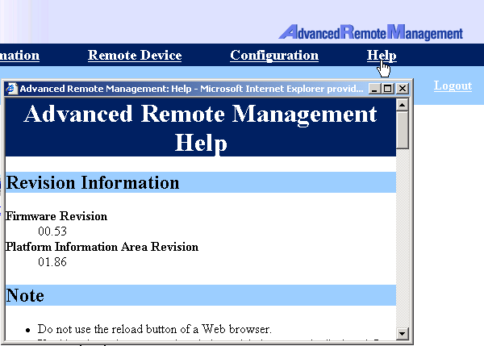

What’s the difference with new firmware ?

When firmware have been flashed, you have the possibility to select either French or English keyboard layout for remote KVM

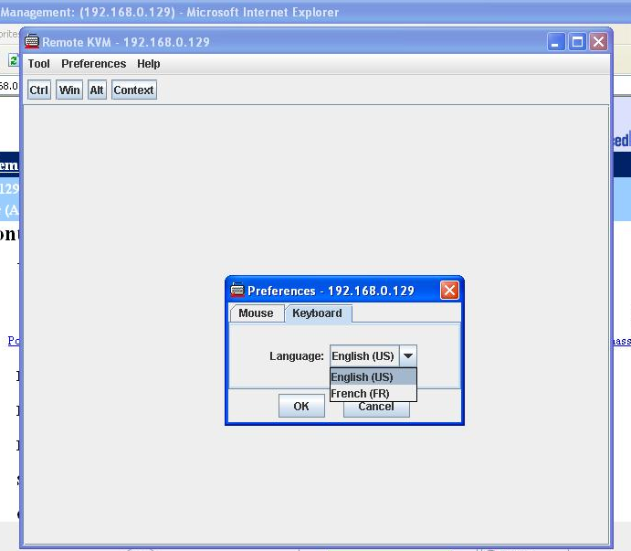

Important note:

In order to use this new firmware, Java Virtual machine has to be updated to version 1.5.0 minimum. Refer to latest Expressbuilder to get it.

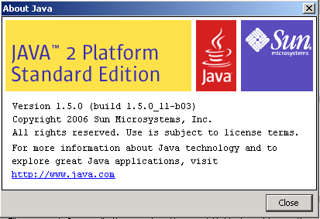

Document owner: | COE Servers
Applies to: | All server offering Expressscope features (R440, R460, T860, T820…)

