
Technical Information Document
COE
Servers

Document Title: | ExpressScope login issues
Document ID: | TID0705281624
Creation Date: | 28 May 2007
Modified Date:
Document Revision: | 0
Product Class: | Servers
Product and Version: | Server with ExpressScope (R440, R460, T820, T860)

Symptoms / Facts

Immediately after log in and password validation, you received the following error:

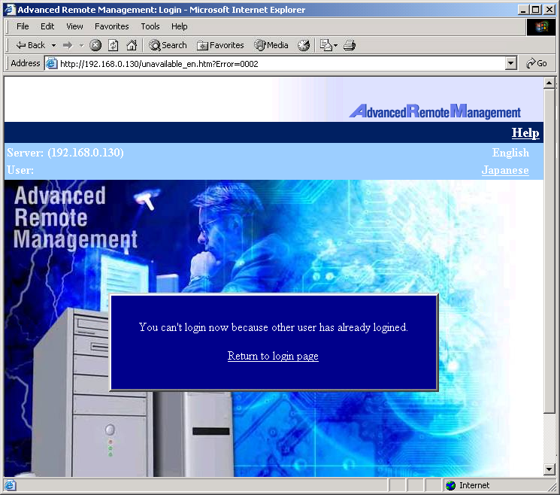

Cause

It happens when user didn’t disconnect using the logout feature

Solutions / Fixes

Delete cookies of internet browser.
No need to close the internet browser session or clearing history.

See also (if applicable)

Document owner: | COE Servers
Applies to: | Server with ExpressScope (R440, R460, T820, T860)

