
Technical Information Document
COE
Servers

Document Title: | Proper mouse setting to use KVM over IP (=”Remote KVM”) of Expressscope
Document ID: | TID0705281632
Creation Date: | 28 May 2007
Modified Date: | -
Document Revision: | 0
Product Class: | Servers
Product and Version: | All server offering Expressscope features (R440, R460, T860, T820)

Symptoms / Facts

Mouse cursor doesn’t respond properly on server using Remote KVM feature. Some areas of the desktop are not reachable.

Cause

Mouse cursor setting on server and client side.

Solutions / Fixes

The following settings have to be done:

On server side (= machine with Expressscope):

- For Windows 2003, uncheck “Enhance pointer precision”
- For Linux, adjust the movement of the mouse cursor using [Mouse Preference]-[Motion]-[Acceleration].

No specific mouse settings on client side.

On client side (remote machine)

- Open “Remote KVM” window and go to Preferences/Preferences… and set the following:
  - Cursor : Dual
  - Mode : Absolute

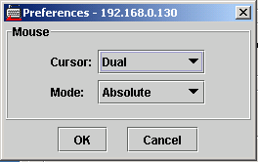

Note: For such settings, check that following video settings are default (Display Properties / Troubleshoot: Hardware acceleration to “Full”).

Document owner: | COE Servers
Applies to: | All server offering Expressscope features (R440, R460, T860, T820)

