
Technical Information Document
COE
Servers

Document Title: | Error using ESMPro Web Component (Failed to collect information. (System error.(OpenFileMapping (5)).
Document ID: | TID0706040942
Creation Date: | 4 June 2007
Modified Date:
Document Revision: | 0
Product Class: | Servers
Product and Version: | ESMPro

Symptoms / Facts

After connecting to ESMPro Web Component URL http:/localhost/esmpro, the following screen appears:

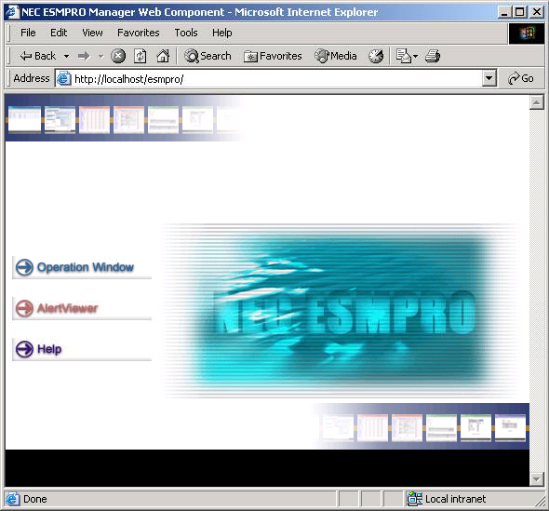

When clicking on Operation Window, the following error appears:
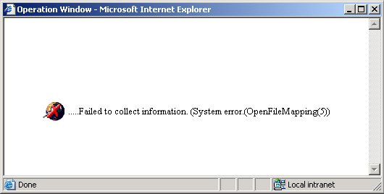

Cause
Incorrect IIS security settings

Solutions / Fixes
Apply the following settings :

Note: These settings are not the most secured (password is sent in clear text over the network), but it allows validating the configuration.

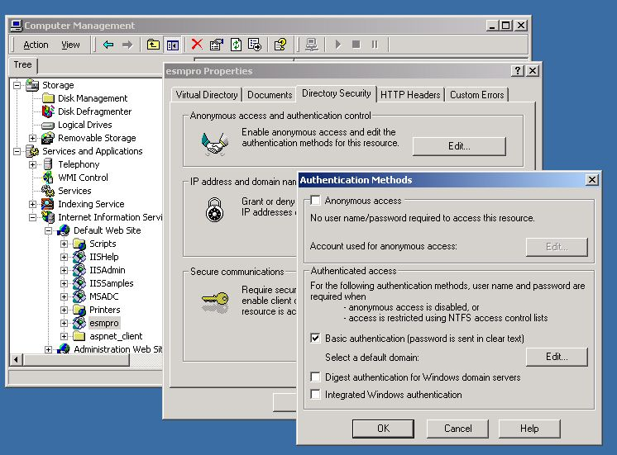

Document owner: | COE Servers
Applies to: | ESMPro

