
Technical Information Document
COE
Servers

Document Title: | How to handle URU alerts on Alert Viewer of ESMPro Manager ?
Document ID: | TID0801251012
Creation Date: | 25 January 2008
Modified Date:
Document Revision: | 0
Product Class: | Servers
Product and Version: | Servers using URU and ESMPro Manager

Symptoms / Facts

In following configuration:
- An Bull server with Universal RAID Utility and ESMPro Agent
- A PC with ESMPro Manager
- ESMPro Alerts (including URU alerts) sent to ESMPro Manager

Alerts are received properly as follow on this screenshot. URU Alerts are properly identified and typed as “URAIDUTIL”

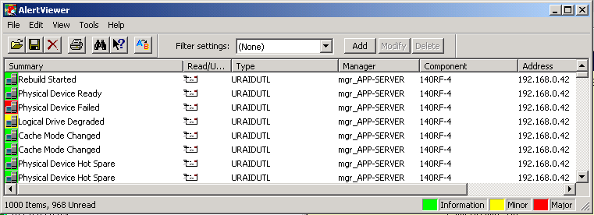

In case of alert forwarding, Alert Report of ESMPro Manager has to be used.

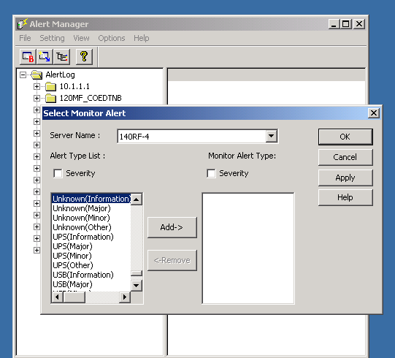

Here the “URAIDUTIL” alerts are not listed. As consequence, the URU events cannot be redirected by mail for example

Cause

There is a missing entry in ESMPro Manager. It has been seen on all version until version 4.32. Future correction has not been confirmed.

Solutions / Fixes

- Stop ESMPro Manager
- Apply the attached .REG file on ESMPro Manager.

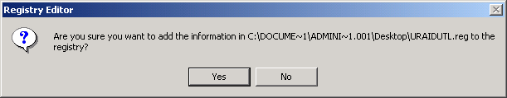

- Start ESMPro Manager and check Alert Report. As consequence, the missing entry has been added

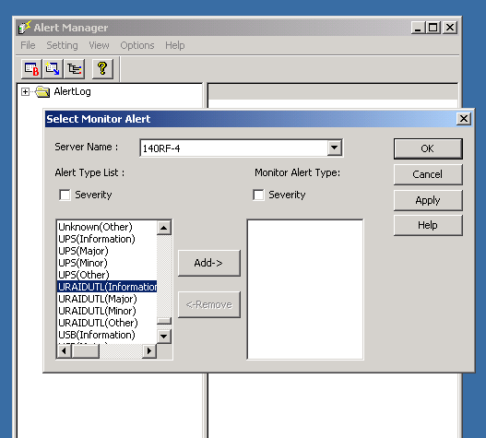

Document owner: | COE Servers
Applies to: | Servers using URU and ESMPro Manager

